**King Fahad university of petroleum and minerals**

**Information and computer science department**

**ICS108 Lab project**

Done by:

1- Mohammed

ID: 2019*****

Section: 5

2- Khaled

ID:2019*****

Section: 1

**Project description:**

The main object for this project to design a question bank program that let the user enter questions and answers and edit it, show it, also delete any question he wants by using JavaFX and binary I/O in java.

**Solution Description:**

In our program we divide our work into 4 steps:

**1- Main class**

Here we create the first and the main stage in our program, in picture:

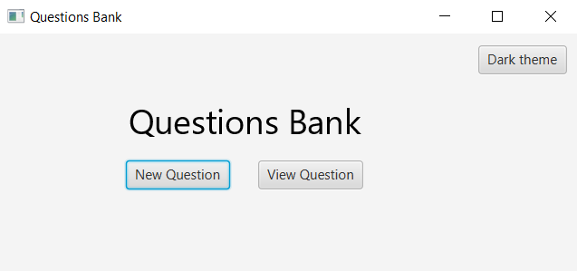

It let the user to select either add a question or edit a question that he added previously if the user select (New Question) option, the program will show another scene for create a question.

**2- New scene class**

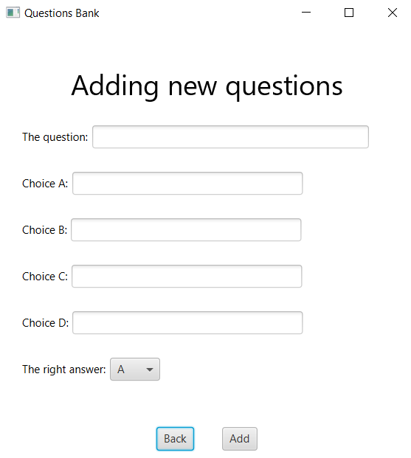

This step will provide 6 options for the user, add the question and enter the 4 choices for the answers, and which one is the right answer (by default the right answer is A until the user changes it) and the program will show error massage if the user didn’t enter the enough information.

And after write the question and the answers the program will save them into an array of class type Question and write the array into the binary file.

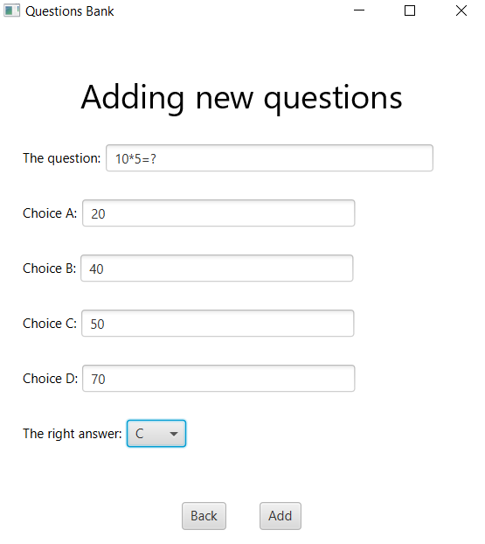

**3- View scene class:**

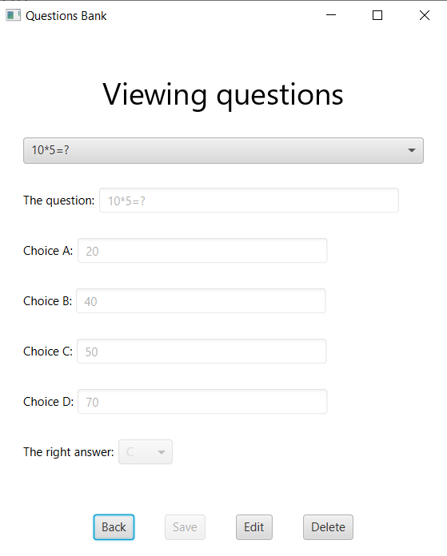

In the main menu if the user selected (View Question) the above Scene will be shown, here this step provides 5 options for the user:

A- the above menu will let the user to select any question in the file to see it or change anything in the question (by default it will show the last question added by the user).

B- Back: back to the main menu.

C- Save: it will save the changes that user done either edit or delete question.

D- Edit: it will let the user to change the question or the answers,

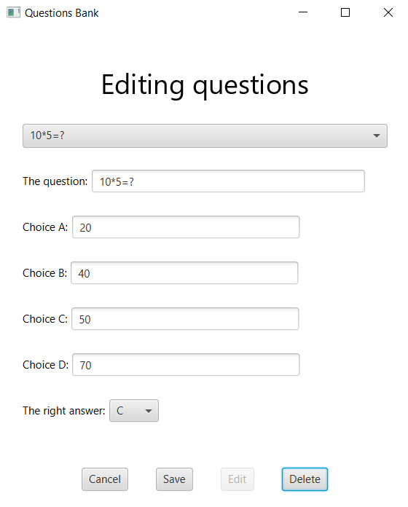

The user can do anything on the question in this step.

E-Delete: it will let the user to delete the question and will show a massage ask the user if he sure or not about deleting the question.

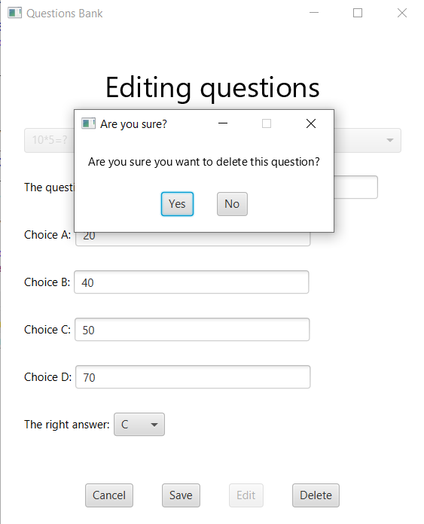

Every change that happens by any of the above option will change the array and wrote it again in the file.

**4- Question class:** we set constructor that take the question and the answers and the right answer and used setter and getter methods to set and get them and we override toString method to return the question.

**5- Extra tool**:

we provide an option to change the theme of our program to dark theme:

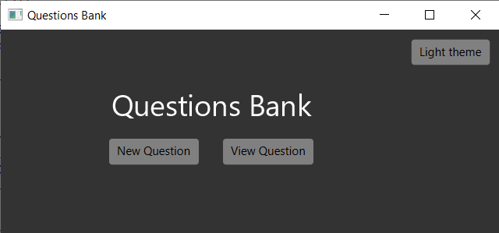

**Work Distribution:**

We used an extension to Eclipse IDE called Saros that allowed us to work together simultaneously, and we worked together almost all the time.

**Problem we faced during the project:**

When the list is empty after deleting all the questions It was giving us index out of bounds or null exceptions, but we put a default object that says, "please add a question first" and lock all the buttons to prevent the error happening, and when the user adds a question, the default get removed also the default object is never saved in the file.